

**Tribhuvan University**

**Faculty of Humanities and Social Sciences**

# **BLOOD BANK MANAGEMENT SYSTEM**

**A PROJECT REPORT**

**Submitted to**

## **Department of Computer Application**

**Arniko College**

**Bhanimandal, Lalitpur**

***In partial fulfillment of the requirements for the Bachelors in Computer Application***

Submitted by:

Gobinda Pd Jamakatel (TU roll no:)

Nitesh Mahat (TU roll no:)

February 20

Under the supervision of



**Tribhuvan University**

**Faculty of Humanities and Social Sciences**

**Arniko College**

**Bhanimandal, Lalitpur**

## Supervisor’s Recommendation

I hereby recommend that this project be prepared under my supervision by Gobinda Pd Jamakatel and Nitesh Mahat **entitled “BLOOD BANK MANAGEMENT SYSTEM”** in partial fulfillment of the requirements for the degree of Bachelor of Computer Application is recommended for the final evaluation.

**SIGNATURE**

Gobinda Pd Jamakatel

Nitesh Mahat

SUPERVISOR

Lecturer

BCA Department

Arniko College

Bhanimandal, Lalitpur



**Tribhuvan University**

## **Faculty of Humanities and Social Sciences**

**Arniko College**

**Bhanimandal, Lalitpur**

**LETTER OF APPROVAL**

This is to certify that this project was prepared by Gobinda Pd Jamakatel and Nitesh Mahat **entitled “BLOOD BANK MANAGEMENT SYSTEM”** in partial fulfillment of the requirements for the degree of Bachelor in Computer Application has been evaluated. In our opinion, it is satisfactory in the scope and quality as a project for the required degree.

| **Signature of Supervisor**  **Name of Supervisor**  **BCA Department**  **Arniko College**  **Bhanimandal, Lalitpur** | **Signature of Campus chief**  **Name of Campus chief**  **Arniko College**  **Bhanimandal, Lalitpur** |
| --- | --- |
| **Internal Examiner** | **External Examiner** |

**Araniko College of Business and Technology**

**Ref no:**

**Date:**

**Subject: Approval of project proposal**

The project entitled “Blood Bank Management system” proposed by Mr. Gobinda Pd Jamakatel and Mr. Nitesh Mahat for the partial fulfillment of the requirement for Bachelor in Computer Application (BCA), the fourth semester has been approved for further development.

**Proposal Evaluation committee**

**1. _______________**

**2.________________**

**3.________________**

**4.________________**

**_________________**

**Mr. Campus Chief(.)**

**ABSTRACT**

Blood Bank Management System is a web-based system that helps to manage all the related work and stuffs inside a blood bank, which includes handling blood and donation requests, bloodstock management, etc. It provides an interface for the blood donors and blood receivers.

This project can help people for connecting to the blood bank directly through the system for quick service. The main aim of this project is to make the blood bank management system effective and to make the collection and distribution of blood digital.

**Contents**

Chapter 1 Introduction……………………………………

1.1 Introduction of Proposed project………………

1.2 Problem Statement………………………………….

1.3 Objectives…………………………………………….

1.4 Scope and limitation…………………………………..

Chapter 2 Literature Review………………………………

Chapter 3 Methodology……………………………………

3.1 System Analysis……………………………………….

3.2 System Design…………………………………………

3.3 Project Schedule…………………………………….

Chapter 4 Conclusion…………………………………

4.1 Expected Outcome………………………………….

References………………………………………………

Bibliography…………………………………………….

**Chapter 1 Introduction**

**1.1 Introduction to Proposed project**

A blood bank is a centralized place that stores blood for its distribution. It collects blood from donors and other sources and provides blood to needy people or hospitals. In a blood bank, there would be various processes and tasks between the collection and distribution of blood. It is designed for handling those tasks and processes effectively and easily. It also provides the platform for end-users to donate and request blood.

This system will provide the interface for 3 types of users. One is a Super-admin who creates an account for the blood bank manager(i.e, Admin) and handles the role and permission of the system. The second one is the Admin or Blood bank manager who manages an inventory of blood in the blood bank, handles blood requests and donation requests, manages donors and patients, etc. And the last user is a client who can request the blood as a patient or can make the donation request as a donor. In this system, a donor can be a patient and also a patient can be a donor with equal permission.

In this system, the super-admin can create its account and log in to the system. It can create, view, update and delete other users of the system. Super-admin also plays its role in managing roles and permissions of the system. The blood bank manager (Admin) logs in into the system with the credential created by super-admin. This user is responsible for handling donations and blood requests, viewing and updating the blood stock with each blood group, can generate the blood certificates and blood request tokens, managing the clients and their history. The clients have to first register to our system by filling up different type of details. After they logged in into the system, they can make blood requests and also can make donation request by filling up the form. They can manage and edit their profiles as well.

Inside the system, There will be the relationship between donor, patient, and the admin of the system. Donor makes the donation requests, if the donation request is approved and donation is completed then that amount of blood will be added to the stock by admin, generates donation certificate and send it to the donor. Also, patients requests the blood, system will check there is available stock for requested blood or not, If the blood is available, admin will approve the request and that amount of blood is reduced from the stock.

**1.2 Problem Statement**

The problem of the blood bank management system in Nepal are listed below:

* There is a Lack of a computerized Database Management System, data, or information which are in a file format is hard to access, and it takes a lot of time to give output.
* There may be a chance of a system crash or data stolen in the file system due to a weak database management system.
* There is no centralized database of volunteer donors. So, it becomes tedious for a person to search the blood in case of an emergency.
* Service may be slow, or the system may be inactive during emergencies for patients.

**1.3 Objectives**

Main objectives of this project are listed below:

* To develop a system that makes management of blood banks easy and to provide a platform for the donors and receivers.
* To improve the efficiency of bloodstock management by alerting the blood bank staff when the blood quantity is below its par level or when the bloodstock is expired.
* To store a proper computerized database of blood, donors, and receiver.
* To allow the patients to make search and match the blood group and make requests for the blood.
* To give quick responses to the patients when they need the blood in emergency cases.

**1.4 Scope and limitation**

**1.4.1 Scope**

* Blood bank management system will be the web-based system which will be implemented in HTML, CSS, JS in frontend and Django at the backend.
* It will provide the platform for donor, patient, and blood bank.
* Clients will be able to donate and request the blood.
* Clients will be able to view the blood stock and make the order accordingly.
* Blood bank manager will be able to manage blood bank with great efficiency and easily.

**1.4.2 Limitation**

* This system requires an internet connection and user must be a computer-literate person.
* This system is a web-based system, and its mobile application is not Available.
* For the people in the rural areas with not stable internet facility may not be able to use this system.

**Chapter 3: Methodology**

**3.1 System Development Methodology**

To develop this system, we’ve use traditional waterfall method as we are clear with our requirements and features for the system. It is the linear project management approach. At the beginning of the project, all the requirements are gathered, and a linear project schedule is also created. This model is effective and fast to use when we’ve all the information about our system’s requirementsand requirements won’t be changed often. It is a simple model with ease of use. As this is the sequential approach to develop a particular system, it’s next phase is started only after the completion of the current phase and cannot be returned.  
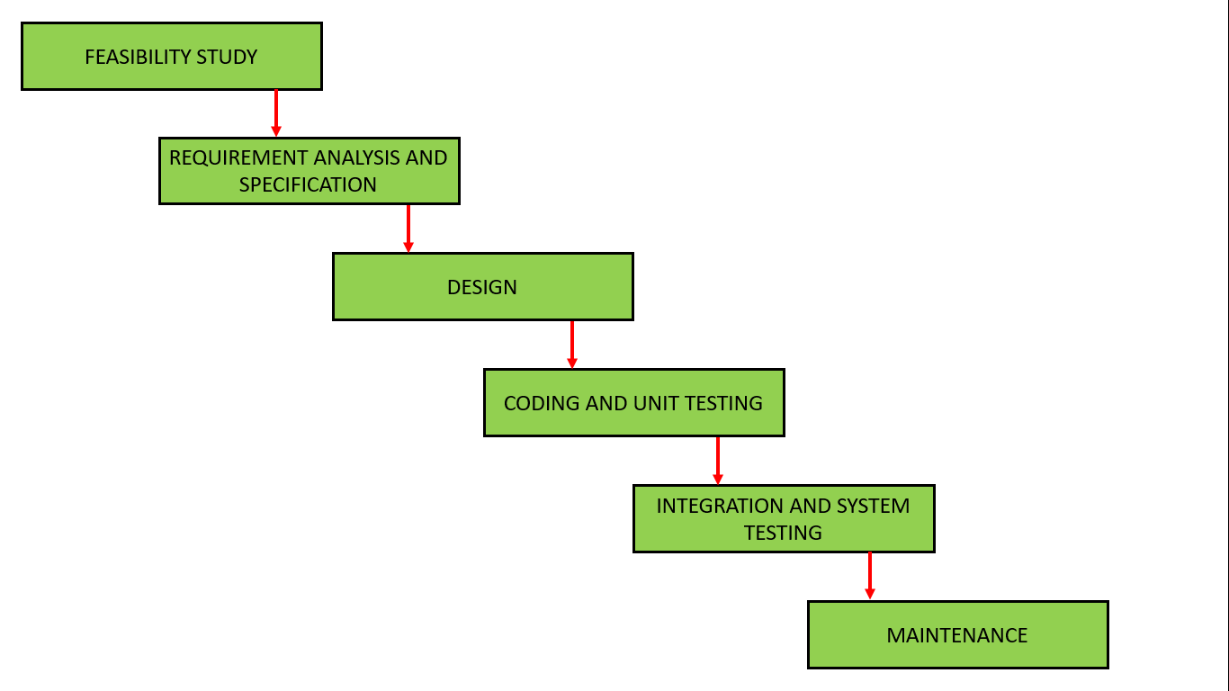

**3.2 System Analysis**

System analysis is the phase in which facts and information are collected, problems are identified, and the system is decomposed into its components. Mainly, system analysis is done for the purpose of understanding the purposed system and to identify its objectives and goals. In simple words, at the end of the phase, it is identified that what actually the system should do. This phase is helpful to know about the business needs and process needs.

**3.3 Requirements of the system**

**3.3.1 Functional requirements**

* User registration(Donor/Patient).
* User login/logout/profile update and management.
* Request for blood.
* Request for blood donation.
* Request handling.
* Blood stock management.
* Individual records.

**3.3.2 Non-functional Requirements**

* Maintainability
* Flexibility
* Security
* Availability
* Performance
* Scalability
* Feasible

**3.4 Feasibility study**

**3.4.1 Technical feasibility**

Technical feasibility study defines to understand how feasible is the purpose system will be technically. Is that system is technically acceptable or not? Do we have all the required Technology for developing the purposed system or not? Or do we have that enough technical knowledge to develop the purposed system or not? These are the questions of which the technical feasibility study has to answer.

Here, In our case, there is no technical barrier for the development of our system.

**3.4.2 Economical feasibility**

This defines how much is the system is economically feasible or cost-effective. This will help to measure if the purposed system is economically feasible or not, to develop that system by the proper calculation and estimation of cost, and it’s future possible incomes.

In our case, excepting the cost of internet, there are no other cost to develop our system. So, this project has no economical barriers.

**3.4.3 Operational feasibility**

This feasibility study measures how easy is the system is to operate it. After the completion of our system, there will be no hurdles to use our system. This system will be easy to use because of the user-friendly interface. To use our system, any well-trained people are not required, a person with minimum understanding of English language can easily operate our system.

**3.4.4 Schedule feasibility**

This project is feasible to complete within the given schedule. We clearly know, it’s functional, non-functional requirements. It is a small management system project, and also we are clear on our goal, we know the technical requirements. So, it is feasible to complete our project within a time.

**Gantt chart**

**Tools we use:**

* **Frontend**
  + HTML
  + CSS
  + JS
  + Bootstrap
* **Back-end**
  + Python
  + Django

**Chapter 4: System Design**

**4.1 ER Diagram**

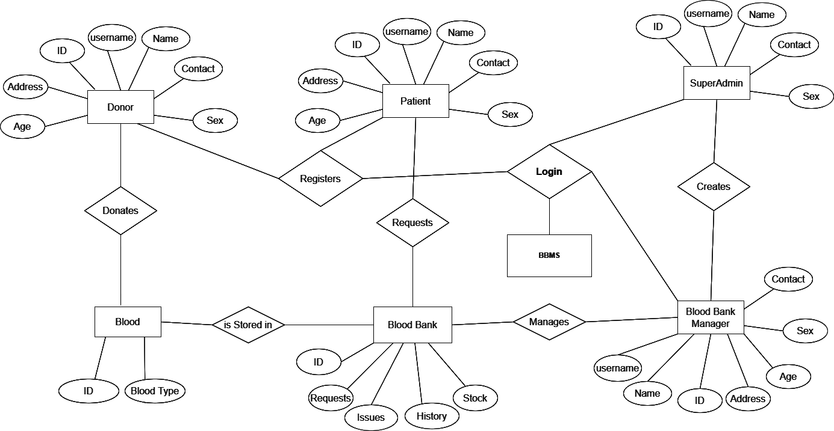

**4.2 Use Case Diagram**

**4.2.1 Use Case for Super-admin**

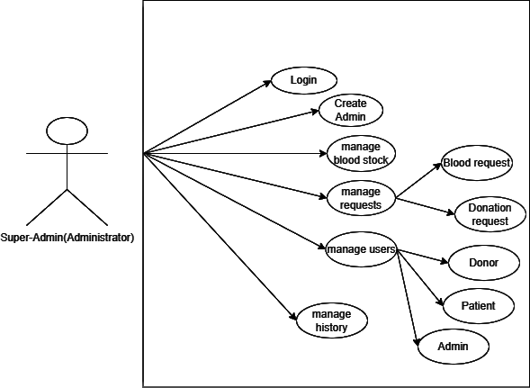

**4.2.2 Use Case for Blood Bank Manager(Admin)**

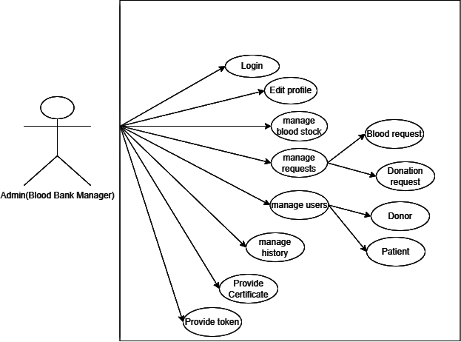

**4.2.3 Use Case for Clients(Donor/Admin)**

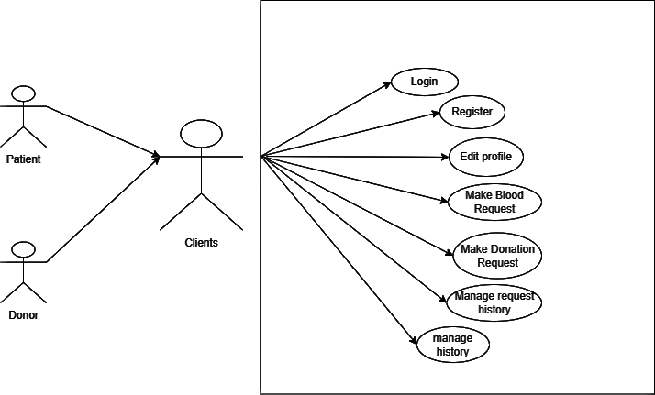

**Chapter 4 Conclusion**

This project will be really helpful for solving the issues towards the blood bank management. People can rely on this system to donate the blood and request blood. This system has the betterment in the user interaction and transparency of blood stock. Through this platform, any people can be connected to the blood bank easily when emergency. Our system has feedback system that help us to improve the system accordingly.

**4.1 Expected Output**

When the project is completed, blood bank management will be easier and effective. People will be able to connect digitally with the blood bank for blood donation and blood request. This will improve in transparency on the blood stock in blood bank. People who donate the blood will get the blood donation certificate for their appreciation.

|  |
| --- |